
Newsletter 4
Welcome to our fourth newsletter for the Methven Rodeo Club Springston Trophy to be held in Ashburton Thursday October 1st to Sunday October 4th, 2026.
Team Entry Deadline is Approaching!
Delighted to report we now have 24 teams nominated.
Next step is to place your final team entries and enter draft riders using Evo Events www.evoevents.co.nz Closing date for team and draft rider entries is Friday 4th September 2026. The closing date for composite team entries is Friday 11th September.
The team entry fee is $600 ($500 if you have already paid your nomination).
How the draft rider register will work

Once draft riders have been entered by their club, their name, class and horse name will be on Evo Events www.evoevents.co.nz teams wanting a draft rider can see who is available (they should keep returning to the site as names will be added). Due to privacy requirements, teams must email the ST committee springstontrophy2026@gmail.com to obtain contact details for the draft rider. An agreement document will then be signed by both parties if a fit is found.
Who is attending the AGM from your Pony Club?
The Annual General Meeting of Delegates from each Pony Club will be held 6pm Friday October 2nd. Each South Island Pony Club is entitled to be represented by two delegates who will each have one vote. Delegates must be nominated in writing by their Club, at the close of team entries to be eligible to vote. The form to nominate AGM delegates is attached to this email, please email completed forms to springstontrophy2026@gmail.com by Friday 4th September.
Updates will be posted on:
- Our Facebook page “Springston Trophy 2026”
- The Sporty link https://www.sporty.co.nz/springstontrophy/home-1
- Emailed to the NZPCA contact for your pony club
Event Timetable:
Wednesday September 30th - Teams may arrive from 3pm & settle in at Ashburton A&P Grounds
Thursday October 1st – Welcome & Cross-Country Walk at the Rakaia cross country course
Friday October 2nd – Dressage at Ashburton A&P Show Grounds
Friday Evening – AGM at 6pm upstairs above the grandstand
Saturday October 3rd – Cross Country, teams will travel to Rakaia for cross country
Saturday Evening – AgriMagic “Burgers & Bubbles” Horseless Teams Event. Dress up and compete in this fun team event. BBQ to follow. BYO alcoholic drinks, bring camp chairs, picnic blankets and a sense of fun!
Sunday October 4th – Show Jumping & Mounted Prize Giving at Ashburton A&P Show Grounds
Methven Rodeo Club backs Springston Trophy 2026
Methven Rodeo Club is now our official naming rights sponsor and we couldn’t be more thankful for this outstanding contribution. To have a club with such a great depth of horse mastership experience provide this level of financial support for the development of young pony club riders means so much. We are delighted our local cowboys and cowgirls share our passion for youth equestrian development.
The Methven Rodeo is one of the largest and most popular rodeos in New Zealand, drawing a crowd of over 6,000 spectators at the Methven A&P showgrounds on the Sunday of Labour weekend. The family-friendly event showcases top national cowboys and cowgirls competing across multiple rodeo disciplines.
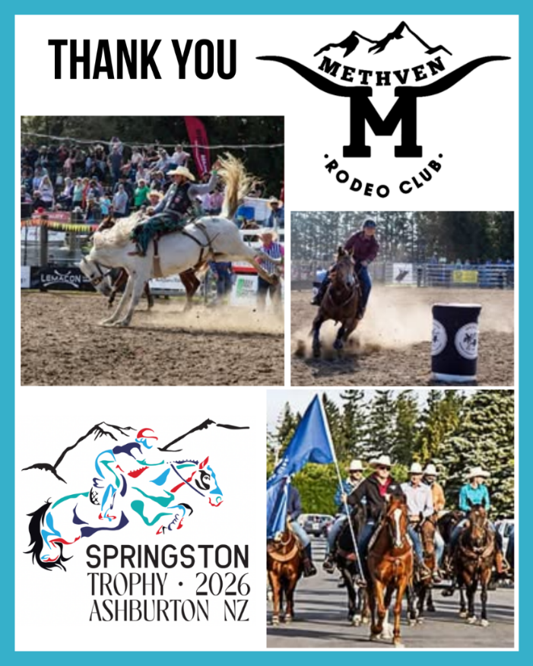
Help Us Say Thank You!
We are enormously proud of the way our community has backed Springston Trophy 2026 with a mix of financial contributions, building material donations, labour, expertise, transport, raffle purchases and fabulous products for prizes. There are a multitude of ways you can say thank you, a few suggestions:
Socials
Follow our Facebook page “Springston Trophy 2026” where we will be thanking sponsors individually, like, comment and share these gratitude posts with your FB friends.
When you spot a sponsor logo on the cross-country course, show jump rings or by the dressage arenas snap a pic and share it on your social media, tag the sponsor and shout them out for their kindness.
A Personal Thank You
Visit sponsor trade display at the event and thank them in person.
Email, Message or Mail sponsors a thank you, our event program will include an email address for each sponsor. Go one better and include a photo of yourself, your mount or your team and tell sponsors what you gained from the event.
Choose them for purchases
Let your wallet do the talking and let them know you spotted their sponsorship.
Officials & Volunteers
Giving time and expertise for free is always a generous act so please take the time to personally thank our many helpers.
Platinum Sponsors
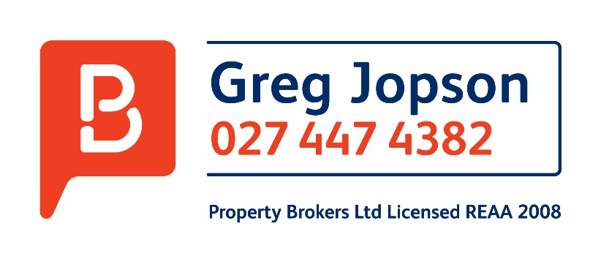



Rakaia Lions Club


Back Track Dairies Limited
Gold Sponsors
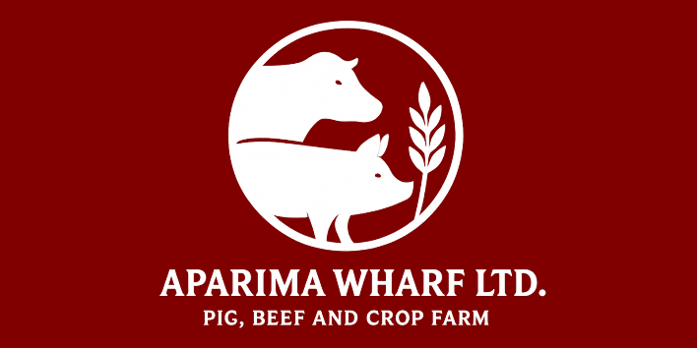



Casey & Solly Ltd

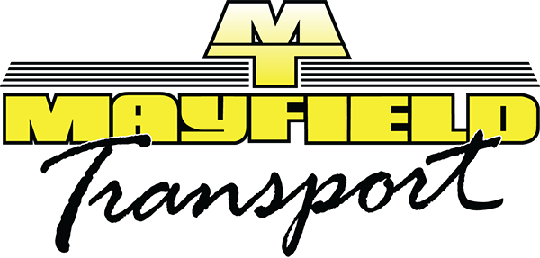

Aoraki Region Pony Club
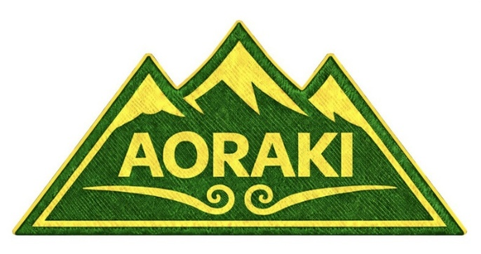
Silver Sponsors







All Sponsors

Methven Rodeo Club  Community Trust of Mid & South Canterbury  The Lion Foundation  Ashburton District Council  Greg Jopson Property Brokers  Golden Bay Dolomite  Mainland Coachwork  Fourflax  Rakaia Lions  Jackson Holmes  Agrimagic  Whiterock Quarry  Philip Wareing Ltd, Rural Transport Ltd, Wilsons Bulk Transport Ltd, Mayfield Transport Ltd  Aoraki Region Pony Club  Cochrane’s of Canterbury Ltd  Aparima Wharf Ltd  Bayleys Real Estate, Methven  Rangi Ruru Girls School  Crombie Lockwood  EA Networks  Molloy Ag  Progressive Livestock  Rakaia River Holiday Park  WaterForce  Rakaia Mobil  Rainer Irrigation  Cates Seeds  Tamar Farms  Lushingtons Nursery  FMG Insurance  Rosa Dekker, Bayleys Methven  Lushingtons  Robsons  Ashburton Toyota  Ashburton U-Hire  Atlas Trailers  ASB  Carrfields  Woolworths  Crichel Potatoes  Dairy Vets  Dairycool | Gallagher Insurance  Evolution Vets  RIG Construction  Harmer Earthmoving  Elgin Transport  Tree Tech  RuralCo  D&A Fencing Ltd  Watson Digging  David Brady Painting & Decorating  Quigley Contacting  Plains Power  Peter Letham  Miles Family  MAD Graphics and Signz  Melwood Equestrian  The Stable Door Equine  Cover Queen  Canter4 Cancer  Nele Svenson – Equine Bodywork & Activmed  Dunstan  ANZCO Foods Five Star Beef  Her Hire Limited  Daydream Miniature Horses  Morrisons Saddlery  Forsyth Barr  Beyond the Bit  Goldpine  Glen Atford (McAthur Family)  Okawa Herefords  Back Track Dairies Ltd  Casey & Solly Ltd  BJ & MA Stock  Kiwi Country Pet Food  Diesel Tech  Donaghys  Electraserve  Farm First  Farm Focus  Farm Source  Farmlands  Fibrefresh


Please direct all enquiries to our Email: springstontrophy2026@gmail.com
Yarding, Camping and Accommodation Enquires - Kate Moorhead (027 553 3084)
Chairperson - Kim Solly / Event Secretary
Entry Secretary - Janet Cuttle
Event Secretary - Natasha White
Treasurer - Pip Allan / Communications - Mary Stewart and Belinda Bennett
Sponsorship Opportunities - Penny France (021 812 489), Kate Oliver (022 350 5902),
Kate Moorhead (027 553 3084)
Warm regards, Ashburton Pony Clubs - Mill Creek, Methven, Rakaia and Tinwald

